**Poster Abstract Submission Instructions for EWOC 2025**

The 2025 EWOC Conference will be held in hybrid format on June 12–13, 2025.

The **POSTER SESSION** will be **IN-PERSON** on Fri, June 13, at AbbVie, Chicago, IL, USA.

The Poster Abstract Submission window will close on Friday, May 9, 2025.

*Each presenter may only submit one poster abstract.

*The number of posters is limited.

*Abstract acceptances will be emailed by Monday, May 19, 2025. At that time, you will be provided with more information about poster preparation (poster size, etc).

*Space is limited at EWOC 2025; you must register for the conference before you submit your abstract. If your poster abstract is not submitted, you can change or cancel your registration for a full refund.

To submit an abstract for the EWOC 2025 poster session:

1. Please register for EWOC 2025 at <https://cvent.me/WdZ1EW>
   1. For “My role at the conference” please select “Attendee Only.
   2. For you Registration Item, please select “Hybrid In-Person for Poster Presenters (Upon Acceptance).” If there are not remaining seats in this category, you may select “Hybrid In-Person.”
   3. You will receive a link to Poster Abstract Submission in your Registration Confirmation email.
2. Please prepare your poster abstract using the template on the last page of this document. You may see an example abstract on page 2 of this document.
   1. Your abstract must fit within 1 page. Please delete the Instructions and example abstract.
   2. If there is only one institutional affiliation, you do not need to use the notes symbols (†, ‡).
   3. You are welcome to include references in the footnotes.
   4. You are encouraged to include a representative scheme. Color may be included.
3. Save your abstract as a pdf. Name your pdf as LASTNAME-FIRSTNAME-EWOC.pdf
4. Submit your abstract at the link provided in your Registration Confirmation email.
5. You will be notified by Monday, May 19, 2025, if your abstract has been accepted.

If you have any questions, please email [ewoc2025@ewochem.org](mailto:ewoc2025@ewochem.org?subject=Poster%20Abtract%20Submission).

Thank you for submitting an abstract! We look forward to learning about your research and meeting you!

DEAMINATIVE ALKYL-ALKYL CROSS-COUPLINGS OF ALKYLPYRIDINIUM SALTS AND ALKENES

Kristen M. Baker, Diana Lucas Baca, Shane L. Plunkett, Mitchell E. Daneker, Mary. P. Watson*

*Department of Chemistry & Biochemistry, University of Delaware, Newark, Delaware, USA*

*bakekr@udel.edu*

Alkyl amines are inexpensive and widely abundant chemicals in organic synthesis, making them attractive substrates for further functionalization. Functionalization via cleavage of the carbon–nitrogen (C–N) bond has recently been discovered as a powerful transformation of these abundant, easily protected alkyl amines. Due to the prevalence of C(sp3)−C(sp3) bonds in bioactive molecules, methods to create alkyl-alkyl bonds have become increasingly desirable. By using High-Throughput Experimentation interfaced with traditional reaction optimization, we have developed a nickel-catalyzed cross-coupling of alkyl pyridinium salts with an alkyl boron species formed in situ from an alkene.1 The optimization, scope, and mechanistic understanding of these reactions will be presented.

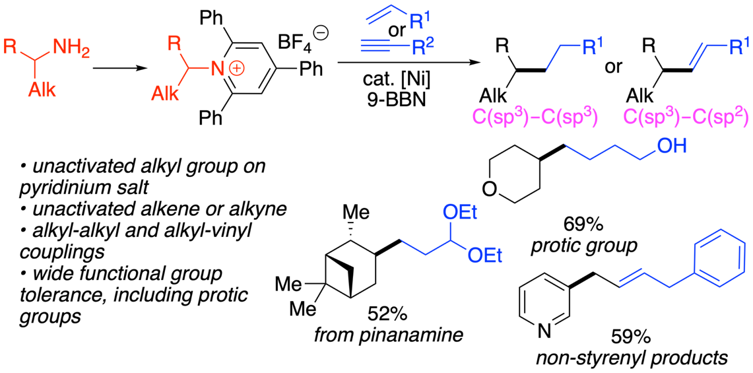

______________________________

1 Baker, K. M.; Lucas Baca, D.; Plunkett, S.; Daneker, M. E.; Watson, M. P. *Org. Lett.* **2019**, *21(23)*, 9738–9741.

Title OF PRESENTATION

Presenting Author and other authors (give first and family name for all authors. Please star* the corresponding author.)

*Affiliation of all authors*

*Address and email of presenting author*

Insert abstract here…...

Insert graphic if you have one…..



_________________________________

1 You may include references at the end of the abstract if you wish.